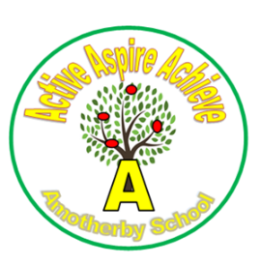
Termly Events – Autumn 2025

Date | Event
17th September | Year 4 trip to Howsham Mill
18th September | Open Morning 9am
8th October | Individual School Photographs
16th October | Family Learning Session 9am – 10.30am
23rd October | Year 5 Science Bus
20th and 21st October | Harvest Festival Donations
23rd October | Harvest Festival EYFS/KS1 9am – 9.45am  KS2 10.45am – 11.30am
24th October | Last day of term and Non-Uniform Day
 | HALF TERM
5th November | Parent Focus Group 2.15pm
10th November | Odd Socks Day
12th and 13th November | Parent’s Evening  12th November – 3.30 – 5.30pm  13th November – 3.30 – 7pm
14th November | Children In Need
17th November | Flu Vaccinations
28th November | SEND Coffee Morning 9am
3rd December | Sparkle and Song a Christmas Showcase 6.30pm
10th and 11th December | EYFS and KS1 Christmas Nativity 2.15pm
12th December | Christmas Lunch
15th December | Year 3 and 4 Christmas Party
16th December | EYFS and KS1 Christmas Party
17th December | Family Learning Session Christmas Crafts 2.15pm
18th December | Year 5 and 6 Christmas Party
19th December | End of term and Non – Uniform Day
 | CHRISTMAS BREAK

Please note that separate letters will be sent out to notify parents of class trips.
Whist every effort will be made not to change the above dates this may be necessary due to factors out of our control.

