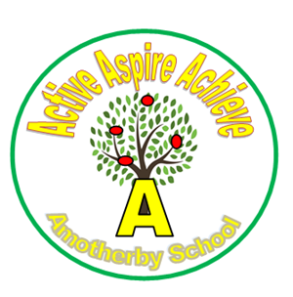
Amotherby Primary School
Meadowfield, Amotherby, Malton, YO17 6TG
Telephone: 01653 693675
www.amotherby.n-yorks.sch.uk
E-mail: admin@amotherby.n-yorks.sch.uk
Headteacher: Mrs Lucy Wade

Friday 24th April 2026

Dear Parents/Carers,

We hope this newsletter finds you well and that you are enjoying the recent spell of brighter weather. It has been a busy and productive time here at Amotherby School, with lots of exciting developments taking place across the school. We are very proud of the children’s continued enthusiasm and positive attitudes, and we would like to take this opportunity to share some important updates and information with you.

Lunchtime Play Project – Donations Welcome
We are very pleased to be introducing a new lunchtime play project, designed to further enhance the quality and variety of play experiences available to our children. As you are aware, we have recently zoned the school field to create different areas for different types of play. Our aim is to ensure that all children, including those who prefer quieter and more imaginative activities rather than sports, have access to engaging and enjoyable play opportunities.

To support this project, we would be extremely grateful for donations of suitable play items.

In particular, we are looking for:
- Dolls
- Dolls’ pushchairs
- Small world toys
- Dressing-up clothes
- Toy figures, animals, or similar imaginative play resources
- Blankets
- Any spare plastic boxes you may have

These items will help us create a rich, inclusive play environment where every child can find something they enjoy.

Story Writing Competition
We are excited to announce a Story Writing Competition for all pupils across the school.
This is a wonderful opportunity for children to use their imagination and creativity to write their own stories. We encourage all children to take part and enjoy the process of planning and writing something unique.

The closing date for entries will be Monday 1st June.

All entries must be handwritten, and further details can be found on the accompanying poster. Please take a moment to read this with your child so they understand the expectations. There will be prizes for each age group, with winners receiving a goodie bag of stationery, including notebooks, gel pens and fine liners. We are very much looking forward to seeing the fantastic stories the children create.

Parking Around the Village
We have recently received feedback from residents of Amotherby regarding parking at the beginning and end of the school day. It has been noted that some vehicles are being parked on the main road in a way that can block driveways and cause inconvenience. We kindly ask all parents and carers to park considerately and safely, ensuring that access to local homes is not obstructed. We appreciate your cooperation in helping us maintain positive relationships within our local community.

Parent Survey and Focus Group
We would like to extend our sincere thanks to everyone who completed our recent parent survey. Your feedback is extremely valuable and plays an important role in helping us to continue developing and improving our school. If you haven’t already taken part, we would love to hear your views.
Parent Survey March 2026 – Fill in form

Sun Cream Reminder
With the warmer weather now approaching, we would like to remind parents and carers about our expectations regarding sun protection. If your child brings sun cream into school, please ensure that:
- It is clearly labelled with their name
- It is not an aerosol spray

This will help us ensure that sun cream can be used safely and appropriately during the school day.

Thank You to the PTA
We would like to say a huge thank you to our fantastic PTA for their generous purchase of two composite picnic benches for our Read and Chill area. These benches have already made a wonderful addition to our outdoor space and are being thoroughly enjoyed by the children as a place to relax, read and socialise.

Welcome to Our New Staff
We are very pleased to share that we have welcomed two new members of staff to the Amotherby team this term. A warm welcome to Mrs Duurloo, our new HLTA, who will be working in school on Mondays and Tuesdays and supporting learning across the school. We are also delighted to welcome Mrs Foster, who has joined us as a Midday Supervisory Assistant (MSA). We are sure you will join us in making them both feel very welcome as they settle into life at Amotherby School.

Kind regards,

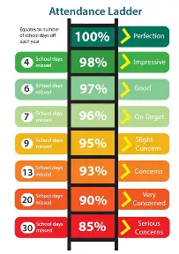
Whole School Attendance
Week Commencing .3.26
%
.

Whole School Attendance
Week Commencing .3.26

%

Yours Sincerely,

Mrs L Wade

